IDEATION PHASE

**2.1 Brainstorm & Idea Prioritization**

|  |  |
| --- | --- |
| Date | 1st , April 2025 |
| Team ID |  |
| Project Name | Convoconnect |
| Maximum Marks | 2 Marks |

2.1 PROBLEM STATEMENT

**"In the current digital landscape, existing video conferencing platforms often come with steep learning curves, cluttered interfaces, unnecessary features, or limitations on free usage. Users — especially students, small teams, freelancers, and educators — seek a simpler, secure, and more intuitive solution for initiating and managing virtual meetings without the need for complex setups or installations. There is a need for a lightweight, browser-based video conferencing application that prioritizes ease of use, quick room creation, privacy, and seamless performance across devices."**

**Customer Problem Statement**

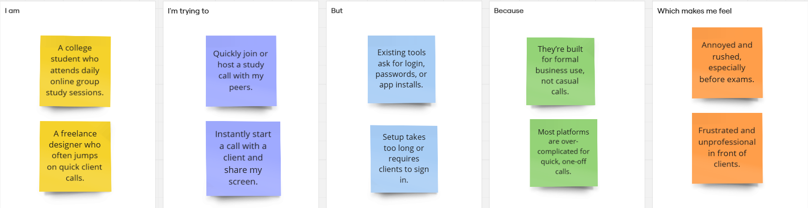

PS-2

PS-1

|  |  |  |  |  |  |
| --- | --- | --- | --- | --- | --- |
| Problem  Statement (PS) | I am  (Customer) | I’m trying to | But | Because | Which makes me feel |
| PS-1 | |  | | --- | |  |  |  | | --- | | **A college student who attends daily online group study sessions.** | | |  | | --- | |  |  |  | | --- | | Quickly join or host a study call with my peers. | | Existing tools ask for login, passwords, or app installs. | |  | | --- | | They’re built for formal business use, not casual calls. |  |  | | --- | |  | | |  | | --- | |  |  |  | | --- | | Annoyed and rushed, especially before exams. | |
| PS-2 | |  | | --- | |  |  |  | | --- | | **A freelance designer who often jumps on quick client calls.** | | |  | | --- | |  |  |  | | --- | | Instantly start a call with a client and share my screen. | | Setup takes too long or requires clients to sign in. | |  | | --- | |  |  |  | | --- | | Most platforms are over-complicated for quick, one-off calls. | | |  | | --- | |  |  |  | | --- | | Frustrated and unprofessional in front of clients. | |

**2.2 Empathize & Discover**

|  |  |
| --- | --- |
| Date | 1st , April 2025 |
| Team ID |  |
| Project Name | Convoconnect |
| Maximum Marks | 2 Marks |

Empathy map for a user (Katherine) using Convoconnect

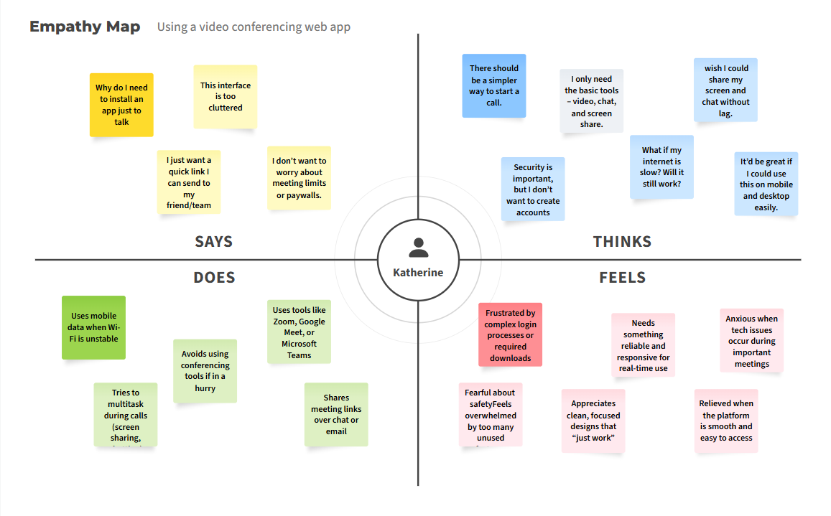

**2.3 Brainstorm & Idea Prioritization**

|  |  |
| --- | --- |
| Date | 1st , April 2025 |
| Team ID |  |
| Project Name | Convoconnect |
| Maximum Marks | 2 Marks |

**Step-1: Team Gathering, Collaboration and Select the Problem Statement**

Problem Statement 1 – Student (Neha, 20):  
I am a college student who attends daily online group study sessions.  
I'm trying to quickly join or host a study call with my peers,  
but existing tools ask for login, passwords, or app installs,  
because they’re built for formal business use, not casual calls,  
which makes me feel annoyed and rushed, especially before exams.

Problem Statement 2 – Freelancer (Aman, 28):  
I am a freelance designer who often jumps on quick client calls.  
I'm trying to instantly start a call with a client and share my screen,  
but setup takes too long or requires clients to sign in,  
because most platforms are over-complicated for quick, one-off calls,  
which makes me feel frustrated and unprofessional in front of clients.

**Step-2: Brainstorm, Idea Listing and Grouping**

Key Ideas:  
- One-click room creation and joining without login  
- Lightweight UI optimized for mobile and web  
- End-to-end encrypted WebRTC communication  
- Built-in chat, screen sharing, and mute toggle  
- Auto-generated room links with expiration  
- Dark mode and virtual backgrounds (future scope)  
- No installation — works directly in browser  
- Option to protect rooms with a passcode

**Step-3: Idea Prioritization**

**High Priority:**- One-click room creation and sharing  
- WebRTC for video/audio/screen share  
- Responsive UI for mobile and desktop  
- Password protection for rooms  
 **Medium Priority:**- In-room text chat  
- Room auto-expiry feature **Low Priority (Future Scope):**- Virtual background  
- AI meeting transcription  
- File sharing and polls